Openstreetmap_h3 Test Review

[GitHub - igor-suhorukov/openstreetmap_h3: OSM planet dump high performance data loader. Transform OpenStreetMap World/Region PBF dump into partitioned by H3 regions PostGIS pgsnapshot (lossless) OSM schema representation and/or into ArrowIPC/Parquet dumps](https://github.com/igor-suhorukov/openstreetmap_h3)

# Introduction

## Why this tool

Excerpt from [How to put the whole world into a regular laptop: PostgreSQL and OpenStreetMap / Habr](https://habr.com/en/articles/717408/) (by the developer, Igor Suhorukov):

*“Why this project needed and what did not suit the existing solutions*

*Attempts to load the planet dump into the PostgreSQL database were long and painful... The* ***Osmosis*** *utility is written in Java, has rich functionality for working with OSM data, and also allows you to load this data into a PostgreSQL database with the pgSnapshot structure for analytics. This project is no longer developed in terms of functionality, only on support. It is possible to convert data from PBF to tsv files for use in a database and there are scripts to create database schemas. The* ***pgSnapshot*** *lossless scheme, which allows you to analyze all available information without loss, build routes, etc. The main disadvantage is the increased table of nodes, which can reach hundreds of gigabytes, which does not allow for a high performant data load in the table and preserving the physical order of records, the long construction of huge indexes, the high price of full scan over a giant table.* ***Osm2pgsql****,* ***Imposm*** *allows you to load data into PostGIS, data import occurs by mapping with the loss of part of the data, is not suitable for routing and is more focused on checking tiles or working with a subset of transformed data in the user requirements table.* ***Osmium*** *export makes scripts faster than osmosis, but PostGIS export functionality is limited and the data model is more primary than in osmosis.”*

## Impressions

This tool is shared “as is”. It is still in development, has no version number, almost no documentation aside from the Readme and blog posts. Some of this documentation is already outdated (API has changed, h3 extension had breaking changes from v3 to v4…). The code lacks comments and the SQL is a bit dirty (inconsistent writing style, unclear naming, commented out codes…). The dependencies are not clear (some are only necessary for Parquet export and Citus columnar storage). It is too dependent on Docker.

For our use case, we don’t need the export to Parquet format. Removing this part would remove the need for several dependencies. The use of Docker is also problematic, it could be replaced with direct calls to external programs. Being able to change the name of the database, etc, would also be nice functionalities to add. All this would require extensive rewriting, but the code is not so big to begin with (~3000 lines).

Docker can be replaced by a call to osmium-tool package on Ubuntu, and an external Postgis-enabled database.

Osmium-tool called for add-locations-to-way and export, in one class, two places:

<https://github.com/igor-suhorukov/openstreetmap_h3/blob/8fb3b4d220f7233dea4f3fe114fbe79d942b2c9f/src/main/java/com/github/isuhorukov/osm/pgsnapshot/ExternalProcessing.java#L107C61-L107C61>

<https://github.com/igor-suhorukov/openstreetmap_h3/blob/8fb3b4d220f7233dea4f3fe114fbe79d942b2c9f/src/main/java/com/github/isuhorukov/osm/pgsnapshot/ExternalProcessing.java#L71>

GNU Parallel might be replaced by xargs: [NAME — GNU Parallel 20231022 documentation](https://www.gnu.org/software/parallel/parallel_alternatives.html#differences-between-xargs-and-gnu-parallel)

# Installation

Clone from Github:

git clone https://github.com/igor-suhorukov/openstreetmap_h3.git



Docker is a necessary dependency, to install on Ubuntu:

sudo apt-get update

sudo apt-get install ca-certificates curl gnupg

sudo install -m 0755 -d /etc/apt/keyrings

curl -fsSL<https://download.docker.com/linux/ubuntu/gpg> | sudo gpg --dearmor -o /etc/apt/keyrings/docker.gpg

sudo chmod a+r /etc/apt/keyrings/docker.gpg

echo \

"deb [arch="$(dpkg --print-architecture)" signed-by=/etc/apt/keyrings/docker.gpg]<https://download.docker.com/linux/ubuntu> \

"$(. /etc/os-release && echo "$VERSION_CODENAME")" stable" | \

sudo tee /etc/apt/sources.list.d/docker.list > /dev/null

sudo apt-get update

sudo apt-get install docker-ce docker-ce-cli containerd.io docker-buildx-plugin docker-compose-plugin



The tool itself can be built within Docker:

cd openstreetmap_h3 && docker build -t openstreetmap_h3



Otherwise, need to install:

* JDK11
* Maven

Then run:

cd openstreetmap_h3 && mvn install

# Usage

## Input file

japan-latest.osm.pbf

## Options

From <https://github.com/igor-suhorukov/openstreetmap_h3>:

~/dev/projects/oss_contrib/openstreetmap_h3$ java -jar target/osm-to-pgsnapshot-schema-ng-1.0-SNAPSHOT.jar

The following option is required: [-source_pbf]

Usage: <main class> [options]

Options:

* -source_pbf

Source path for OpenStreetMap data in PBF format

-collect_only_statistics

Collect only statistics from data - partition distribution

Default: false

-columnar_storage

Use columnar storage in PostgreSql tables for nodes/ways/multipolygon

Default: false

-data_partition_ratio

Filling ratio from maximum size of partition. This parameter change

PostgreSQL partitions count

Default: 0.48

-help

Information about command line parameters

-pg_script_count

Script count for PostgreSQL parallel COPY

Default: 4

-preserve_all_nodes

Preserve all nodes information in case of 'true' or only nodes with tags

or referenced from relations in other case

Default: false

-arrow_format

In case of not null parameter save Arrow data serialization: ARROW_IPC

or PARQUET

Possible Values: [PARQUET, ARROW_IPC]

-result_in_tsv

Save result data in TabSeparatedValue format for PostgreSQL COPY

Default: true

-scale_approx_calc

Approximate scale calculation. Value 'false' - distance in meter

Default: false

-skip_buildings

Skip any ways with 'building' tag

Default: false

-skip_highway

Skip any ways with 'highway' tag

Default: false

-worker_threads

Worker threads count for data processing

Default: 4

## Command

For creating the data necessary for import into database, when using the compiled .jar:

java -jar /data/tool/osm-to-pgsnapshot-schema-ng/osm-to-pgsnapshot-schema-ng-1.0-SNAPSHOT.jar -preserve_all_nodes -source_pbf /data/osm/japan/japan-latest.osm.pbf



If the tool has been installed within Docker, use the following command (not tested, may require changing paths to suit local configuration):

docker run -it --rm -w $(pwd) -v $(pwd):/$(pwd) -v /var/run/docker.sock:/var/run/docker.sock openstreetmap_h3:latest -source_pbf $(pwd)/japan-latest.osm.pbf



For importing the processed data into a database (in Docker):

docker run --name postgis-japan \

--memory=12g --memory-swap=12g --memory-swappiness 0 --shm-size=1g \

-v /data/osm/japan:/var/lib/postgresql/data \

-v /data/osm/japan/japan_loc_ways:/input \

-e POSTGRES_PASSWORD=osmworld \

-d -p 5432:5432 postgres15_postgis:latest \

-c checkpoint_timeout='15 min' \

-c checkpoint_completion_target=0.9 \

-c shared_buffers='4096 MB' \

-c wal_buffers=-1 \

-c bgwriter_delay=200ms \

-c bgwriter_lru_maxpages=100 \

-c bgwriter_lru_multiplier=2.0 \

-c bgwriter_flush_after=0 \

-c max_wal_size='32768 MB' \

-c min_wal_size='16384 MB'



For importing the data to a database outside Docker, see “Modifications > Loading data without Docker”.

# Modifications

## Loading data without Docker

### Dependencies

First of all, a PostgreSQL server with a recent version of the PostGIS extension should be installed. The tool was tested with PostgreSQL 14.10 and PostGIS 3.4.1.

In order to load the data into the database quickly, the tool uses multithreading functionality provided by the package “parallel” ([GNU Parallel - GNU Project - Free Software Foundation](https://www.gnu.org/software/parallel/)):

sudo apt install parallel

It may be possible to replace the use of parallel with the more common “xargs” package with some further modifications.

When loading the multipolygons into the database, the tool uses the extension “h3” (from [GitHub - zachasme/h3-pg: PostgreSQL bindings for H3, a hierarchical hexagonal geospatial indexing system](https://github.com/zachasme/h3-pg)). To install the package:

sudo apt install postgresql-14-h3

### init_db.sh

Get the file “init_db.sh” from the openstreetmap_h3 repository (“/openstreetmap_h3/postgis_docker-master/docker-entrypoint-initdb.d/init_db.sh”) and place it anywhere, for instance in the same root directory as /japan-latest_loc_ways/. Make sure it is executable (“chmod 755 init_db.sh”).

In the file, replace the “/input/” path with the absolute path to the “.../japan-latest_loc_ways/” directory.

[TODO: Put command]

Replace the “"${psql[@]}" <<- 'EOSQL'” part with “psql << ‘EOSQL’”.

[TODO: Investigate this bug better]

### Environment variable

Set the environment variable “$POSTGRES_USER” with the following command:

export POSTGRES_USER=postgres

### japan-latest_loc_ways

Replace “/input/” with the absolute path to the “.../japan-latest_loc_ways/” directory in all SQL files of “/japan-latest_loc_ways/”, for instance with the following command:

grep --include "*.sql" -rl /input/ /data/osm/japan/japan-latest_loc_ways/ | xargs sed -i 's|/input/|/data/osm/japan/japan-latest_loc_ways/|g'

### database_init.sql

Add the following lines at the top of “/japan-latest_loc_ways/static/database_init.sql”:

ALTER SYSTEM SET checkpoint_timeout='15 min' ;

ALTER SYSTEM SET checkpoint_completion_target=0.9 ;

ALTER SYSTEM SET shared_buffers='4096 MB' ;

ALTER SYSTEM SET wal_buffers=-1 ;

ALTER SYSTEM SET bgwriter_delay=200ms ;

ALTER SYSTEM SET bgwriter_lru_maxpages=100 ;

ALTER SYSTEM SET bgwriter_lru_multiplier=2.0 ;

ALTER SYSTEM SET bgwriter_flush_after=0 ;

ALTER SYSTEM SET max_wal_size='32768 MB' ;

ALTER SYSTEM SET min_wal_size='16384 MB';

### Loading the data

Simply run the “init_db.sh” script. For instance, if in the same directory:

./init_db.sh

# Output

## File tree

Root directory is /data/osm/japan/.

### ./

1.8G japan-latest.osm.pbf Original file

25G japan-latest_loc_ways Processed data as SQL files for import

3.1G japan-latest_loc_ways.pbf Processed data as PBF

3.1G japan-latest_loc_ways_blocks Elements making up the processed PBF

### ./japan-latest_loc_ways

3.2M japan-latest_loc_ways/static SQL files for DB creation, etc

53K japan-latest_loc_ways/sql SQL files for importing data

8.2M japan-latest_loc_ways/import_related_metadata TSV files with metadata (stats…)

566M japan-latest_loc_ways/nodes TSV files with nodes data

23G japan-latest_loc_ways/ways TSV files with ways data

80M japan-latest_loc_ways/relations TSV files with relations data

867M japan-latest_loc_ways/multipolygon TSV files with multipolygon data

From here on we will list the files of the subdirectories of “japan-latest_loc_ways” listed above.

### …_loc_ways/static

4.1K ./static/database_init.sql DB and tables creation

6.8K ./static/database_after_init.sql Data import (after nodes & ways)

3.2M ./static/h3_poly.tsv.gz H3 cells geometry

2.5K ./static/multipolygon.sql Data import (to be called from “database_after_init.sql”)

1.1K ./static/multipolygon_tables.sql Table creation (to be called from “database_init.sql”)

134 ./static/osmium_export.json Used when calling osmium to export polygons (in the .jar)

### …_loc_ways/sql

4.1K ./sql/nodes_import_000.sql

3.3K ./sql/nodes_import_001.sql

8.0K ./sql/nodes_import_002.sql

2.9K ./sql/nodes_import_003.sql

6.6K ./sql/ways_import_000.sql

4.9K ./sql/ways_import_001.sql

14K ./sql/ways_import_002.sql

4.6K ./sql/ways_import_003.sql

82 ./sql/y_multipoly_aa.sql

82 ./sql/y_multipoly_ab.sql

82 ./sql/y_multipoly_ac.sql

82 ./sql/y_multipoly_ad.sql

82 ./sql/y_multipoly_ae.sql

### …_loc_ways/import_related_metadata

8.0M ./import_related_metadata/osm_file_block_content.tsv

196K ./import_related_metadata/osm_file_block.tsv

43 ./import_related_metadata/osm_file_statistics.tsv

### …_loc_ways/nodes

2.1K ./nodes/05322.tsv

50K ./nodes/05326.tsv

4.5K ./nodes/05336.tsv

…

144 ./nodes/05342.tsv

514K ./nodes/11777.tsv

4.7M ./nodes/11784.tsv

3.5K ./nodes/11785.tsv

6.3M ./nodes/11786.tsv

…

(149 files)

### …_loc_ways/ways

33K ./ways/05315.tsv

38K ./ways/05322.tsv

…

17K ./ways/05341.tsv

63K ./ways/05342.tsv

48M ./ways/11777.tsv

4.4K ./ways/11779.tsv

…

18K ./ways/19373.tsv

2.5M ./ways/19374.tsv

134K ./ways/20140.tsv

4.6M ./ways/20169.tsv

124M ./ways/32767.tsv

(161 files)

### …_loc_ways/relations

22M ./relations/00000.tsv

59M ./relations/00001.tsv

### …_loc_ways/multipolygon

198M ./multipolygon/multipolygon_aa

109M ./multipolygon/multipolygon_ab

112M ./multipolygon/multipolygon_ac

199M ./multipolygon/multipolygon_ad

252M ./multipolygon/multipolygon_ae

## Database tables

Total database size is 18 GB.

### Partitioned Tables

SELECT

pi.inhparent::regclass AS parent_table_name,

pg_size_pretty(sum(pg_total_relation_size(psu.relid))) AS total,

pg_size_pretty(sum(pg_relation_size(psu.relid))) AS internal,

pg_size_pretty(sum(pg_table_size(psu.relid) - pg_relation_size(psu.relid))) AS external, -- toast

pg_size_pretty(sum(pg_indexes_size(psu.relid))) AS indexes

FROM pg_catalog.pg_statio_user_tables psu

JOIN pg_class pc ON psu.relname = pc.relname

JOIN pg_database pd ON pc.relowner = pd.datdba

JOIN pg_inherits pi ON pi.inhrelid = pc.oid

WHERE pd.datname = 'osmworld'

GROUP BY pi.inhparent

ORDER BY sum(pg_total_relation_size(psu.relid)) DESC;



| **parent_table_name** | **total** | **internal** | **external** | **indexes** |
| --- | --- | --- | --- | --- |
| public.”ways” | 17 GB | 17 GB | 384 MB | 0 bytes |
| public.”nodes” | 553 MB | 552 MB | 600 kB | 0 bytes |
| public.”multipolygon” | 478 MB | 84 MB | 387 MB | 7224 kB |

After additional spatial index creation on ways and nodes (see Visualization):

| **parent_table_name** | **total** | **internal** | **external** | **indexes** |
| --- | --- | --- | --- | --- |
| ways | 19 GB | 17 GB | 384 MB | 1646 MB |
| nodes | 697 MB | 552 MB | 600 kB | 144 MB |
| multipolygon | 478 MB | 84 MB | 387 MB | 7224 kB |

### All tables

After additional spatial index creation on nodes and ways (see Visualization):

SELECT

table_name,

pg_size_pretty(pg_total_relation_size(full_name)) AS total,

pg_size_pretty(pg_relation_size(full_name)) AS internal,

pg_size_pretty(pg_table_size(full_name) - pg_relation_size(full_name)) AS external,

pg_size_pretty(pg_indexes_size(full_name)) AS indexes

FROM (

SELECT table_name, ('"' || table_schema || '"."' || table_name || '"') AS full_name

FROM information_schema.tables

WHERE table_schema='public'

) AS all_tables

ORDER BY table_name ASC;



| **table_name** | **total** | **internal** | **external** | **indexes** |
| --- | --- | --- | --- | --- |
| geography_columns | 0 bytes | 0 bytes | 0 bytes | 0 bytes |
| geometry_columns | 0 bytes | 0 bytes | 0 bytes | 0 bytes |
| geometry_global_view | 0 bytes | 0 bytes | 0 bytes | 0 bytes |
| h3_3_bounds_complex | 16 MB | 12 MB | 40 kB | 4112 kB |
| multipolygon | 0 bytes | 0 bytes | 0 bytes | 0 bytes |
| multipolygon_000 | 32 MB | 9776 kB | 22 MB | 584 kB |
| multipolygon_001 | 17 MB | 6400 kB | 10 MB | 816 kB |
| multipolygon_002 | 20 MB | 4008 kB | 16 MB | 408 kB |
| multipolygon_003 | 49 MB | 15 MB | 33 MB | 1240 kB |
| multipolygon_004 | 51 MB | 11 MB | 39 MB | 904 kB |
| multipolygon_005 | 34 MB | 5264 kB | 29 MB | 456 kB |
| multipolygon_006 | 16 MB | 2152 kB | 13 MB | 192 kB |
| multipolygon_007 | 36 MB | 15 MB | 20 MB | 1272 kB |
| multipolygon_008 | 28 MB | 6128 kB | 21 MB | 480 kB |
| multipolygon_009 | 33 MB | 7312 kB | 26 MB | 536 kB |
| multipolygon_010 | 1768 kB | 280 kB | 1448 kB | 40 kB |
| multipolygon_32767 | 160 MB | 2360 kB | 157 MB | 296 kB |
| nodes | 0 bytes | 0 bytes | 0 bytes | 0 bytes |
| nodes_000 | 38 MB | 30 MB | 40 kB | 8848 kB |
| nodes_001 | 35 MB | 28 MB | 56 kB | 7168 kB |
| nodes_002 | 44 MB | 35 MB | 48 kB | 9760 kB |
| nodes_003 | 168 MB | 132 MB | 72 kB | 35 MB |
| nodes_004 | 76 MB | 60 MB | 48 kB | 16 MB |
| nodes_005 | 47 MB | 36 MB | 64 kB | 11 MB |
| nodes_006 | 14 MB | 10 MB | 40 kB | 3560 kB |
| nodes_007 | 190 MB | 152 MB | 88 kB | 38 MB |
| nodes_008 | 30 MB | 24 MB | 40 kB | 5584 kB |
| nodes_009 | 54 MB | 45 MB | 64 kB | 9416 kB |
| nodes_010 | 936 kB | 728 kB | 40 kB | 168 kB |
| osm_file_block | 552 kB | 520 kB | 32 kB | 0 bytes |
| osm_file_block_content | 13 MB | 13 MB | 32 kB | 0 bytes |
| osm_file_statistics | 8192 bytes | 8192 bytes | 0 bytes | 0 bytes |
| osm_stat_nodes_3_3 | 16 kB | 8192 bytes | 8192 bytes | 0 bytes |
| osm_stat_ways_3_3 | 24 kB | 16 kB | 8192 bytes | 0 bytes |
| raster_columns | 0 bytes | 0 bytes | 0 bytes | 0 bytes |
| raster_overviews | 0 bytes | 0 bytes | 0 bytes | 0 bytes |
| relation_members | 174 MB | 112 MB | 64 kB | 62 MB |
| relations | 24 MB | 24 MB | 112 kB | 0 bytes |
| spatial_ref_sys | 7144 kB | 6896 kB | 40 kB | 208 kB |
| ways | 0 bytes | 0 bytes | 0 bytes | 0 bytes |
| ways_000 | 1403 MB | 1247 MB | 40 MB | 116 MB |
| ways_001 | 1324 MB | 1181 MB | 19 MB | 124 MB |
| ways_002 | 1236 MB | 1101 MB | 24 MB | 111 MB |
| ways_003 | 3987 MB | 3577 MB | 50 MB | 360 MB |
| ways_004 | 1853 MB | 1654 MB | 47 MB | 152 MB |
| ways_005 | 1507 MB | 1342 MB | 41 MB | 124 MB |
| ways_006 | 613 MB | 532 MB | 32 MB | 49 MB |
| ways_007 | 4119 MB | 3712 MB | 24 MB | 383 MB |
| ways_008 | 1159 MB | 1035 MB | 29 MB | 96 MB |
| ways_009 | 1623 MB | 1450 MB | 49 MB | 123 MB |
| ways_010 | 53 MB | 47 MB | 896 kB | 5080 kB |
| ways_32767 | 78 MB | 47 MB | 29 MB | 2072 kB |

### Columns

#### Partitioned table "public.nodes"

Column | Type | Nullable | Storage

--------+----------------------+----------+----------

h3_3 | smallint | not null | plain

h3_8 | integer | not null | plain

tags | hstore | | extended

geom | geometry(Point,4326) | not null | main

id | bigint | not null | plain

Partition key: RANGE (h3_3)

Indexes:

"idx_nodes_geom" gist (geom)

Partitions: nodes_000 FOR VALUES FROM ('-32768') TO ('11800'),

nodes_001 FOR VALUES FROM ('11800') TO ('11816'),

nodes_002 FOR VALUES FROM ('11816') TO ('11872'),

nodes_003 FOR VALUES FROM ('11872') TO ('11880'),

nodes_004 FOR VALUES FROM ('11880') TO ('11888'),

nodes_005 FOR VALUES FROM ('11888') TO ('11944'),

nodes_006 FOR VALUES FROM ('11944') TO ('12120'),

nodes_007 FOR VALUES FROM ('12120') TO ('12136'),

nodes_008 FOR VALUES FROM ('12136') TO ('19296'),

nodes_009 FOR VALUES FROM ('19296') TO ('19368'),

nodes_010 FOR VALUES FROM ('19368') TO ('32695')

#### Partitioned table "public.ways"

Column | Type | Nullable | Storage

--------------------+---------------------------+----------+----------

closed | boolean | not null | plain

building | boolean | not null | plain

highway | boolean | not null | plain

h3_3 | smallint | | plain

h3_8 | integer | not null | plain

scale | real | not null | plain

tags | hstore | | extended

bbox | geometry(Polygon,4326) | not null | main

centre | geometry(Point,4326) | not null | main

id | bigint | not null | plain

linestring | geometry(LineString,4326) | not null | main

points | bigint[] | | extended

h3_8_regions | integer[] | | extended

h3_3_multi_regions | smallint[] | | extended

Partition key: RANGE (h3_3)

Indexes:

"idx_ways_linestring" gist (linestring)

Partitions: ways_000 FOR VALUES FROM ('-32768') TO ('11800'),

ways_001 FOR VALUES FROM ('11800') TO ('11816'),

ways_002 FOR VALUES FROM ('11816') TO ('11872'),

ways_003 FOR VALUES FROM ('11872') TO ('11880'),

ways_004 FOR VALUES FROM ('11880') TO ('11888'),

ways_005 FOR VALUES FROM ('11888') TO ('11944'),

ways_006 FOR VALUES FROM ('11944') TO ('12120'),

ways_007 FOR VALUES FROM ('12120') TO ('12136'),

ways_008 FOR VALUES FROM ('12136') TO ('19296'),

ways_009 FOR VALUES FROM ('19296') TO ('19368'),

ways_010 FOR VALUES FROM ('19368') TO ('32695'),

ways_32767 DEFAULT

#### Partitioned table "public.multipolygon"

Column | Type | Nullable | Storage

--------------------+-----------------------------+----------+----------

h3_3 | smallint | not null | plain

h3_8 | integer | not null | plain

scale | real | not null | plain

tags | hstore | | extended

bbox | geometry(Polygon,4326) | not null | main

id | bigint | not null | plain

centre | geometry(Point,4326) | not null | main

polygon | geometry(MultiPolygon,4326) | not null | main

h3_3_multi_regions | smallint[] | | extended

Partition key: RANGE (h3_3)

Indexes:

"idx_multipolygon_id_h3_3" btree (id, h3_3)

"idx_multipolygon_polygon" gist (polygon)

"idx_multipolygon_scale" btree (scale)

Partitions: multipolygon_000 FOR VALUES FROM ('-32768') TO ('11800'),

multipolygon_001 FOR VALUES FROM ('11800') TO ('11816'),

multipolygon_002 FOR VALUES FROM ('11816') TO ('11872'),

multipolygon_003 FOR VALUES FROM ('11872') TO ('11880'),

multipolygon_004 FOR VALUES FROM ('11880') TO ('11888'),

multipolygon_005 FOR VALUES FROM ('11888') TO ('11944'),

multipolygon_006 FOR VALUES FROM ('11944') TO ('12120'),

multipolygon_007 FOR VALUES FROM ('12120') TO ('12136'),

multipolygon_008 FOR VALUES FROM ('12136') TO ('19296'),

multipolygon_009 FOR VALUES FROM ('19296') TO ('19368'),

multipolygon_010 FOR VALUES FROM ('19368') TO ('32695'),

multipolygon_32767 DEFAULT

#### Table "public.relations"

Column | Type | Nullable | Storage

--------+--------+----------+----------

id | bigint | not null | plain

tags | hstore | | extended

Access method: heap

#### Table "public.relation_members"

Column | Type | Nullable | Storage

-------------+--------------+----------+----------

relation_id | bigint | not null | plain

member_id | bigint | not null | plain

sequence_id | integer | not null | plain

member_type | character(1) | not null | extended

member_role | text | | extended

Indexes:

"pk_relation_members" PRIMARY KEY, btree (relation_id, sequence_id)

Access method: heap

## Miscellaneous

### Polygons in the “ways” table

The table “ways” only has a “linestring” geometry (aside from “center” and “bbox”), but most of the ways (2/3) represent polygons (closed=TRUE):

| **closed** | **count** |
| --- | --- |
| FALSE | 10327041 |
| TRUE | 22385654 |

It could be useful to put the “closed” ways into a separate table, with a “polygon” geometry, as the use cases may be different. Actually, it could be put together with “multipolygon” from the start.

### Output with “-preserve_all_nodes” option

Size of “japan-latest_loc_ways.pbf”: 5.8GB instead of 3.1GB (+87%), size of “japan-latest_loc_ways” directory: 43GB instead of 25GB (+72%).

#### When using “-skip_buildings” as well

Size of “japan-latest_loc_ways.pbf”: 5.8GB instead of 3.1GB (+87%), size of “japan-latest_loc_ways” directory: 31GB instead of 25GB (+24%).

# Visualization

## Extension

Installing the “h3_postgis” extension (from [GitHub - zachasme/h3-pg: PostgreSQL bindings for H3, a hierarchical hexagonal geospatial indexing system](https://github.com/zachasme/h3-pg)) can be helpful, while not strictly necessary. The extension “h3” should already have been installed by the tool when loading the data. See “Modifications” for how to install the package.

CREATE EXTENSION h3_postgis CASCADE;

## Indexes

Some spatial indexes are missing, so it is better to create them before visualizing in QGIS:

CREATE INDEX IF NOT EXISTS idx_nodes_geom ON public.nodes USING gist (geom);

CREATE INDEX IF NOT EXISTS idx_ways_linestring ON public.ways USING gist (linestring);

The index creation takes respectively 19s and 4m16s.

With the options “-preserve_all_nodes -skip_buildings”, they take 38m47s and 1m39s.

## QGIS

From within QGIS, create a PostgreSQL connection to localhost:5432, database “osmworld”, user “postgres” without password.

Add the OSM background map and zoom in on a region (like central Tokyo), in order to avoid loading too much data at once.

Open the PostgreSQL connection and double-click on one of the tables (for instance, public.nodes).

Example of approximately 210,000 nodes over central Tokyo, loading takes around 30s:

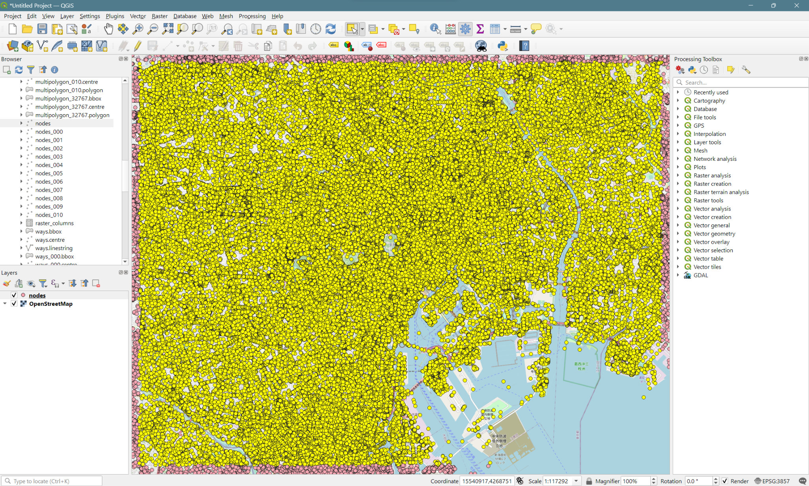

Background map © OpenStreetMap contributors

Example of approximately 1,540,000 ways over central Tokyo, loading takes 30~60s:

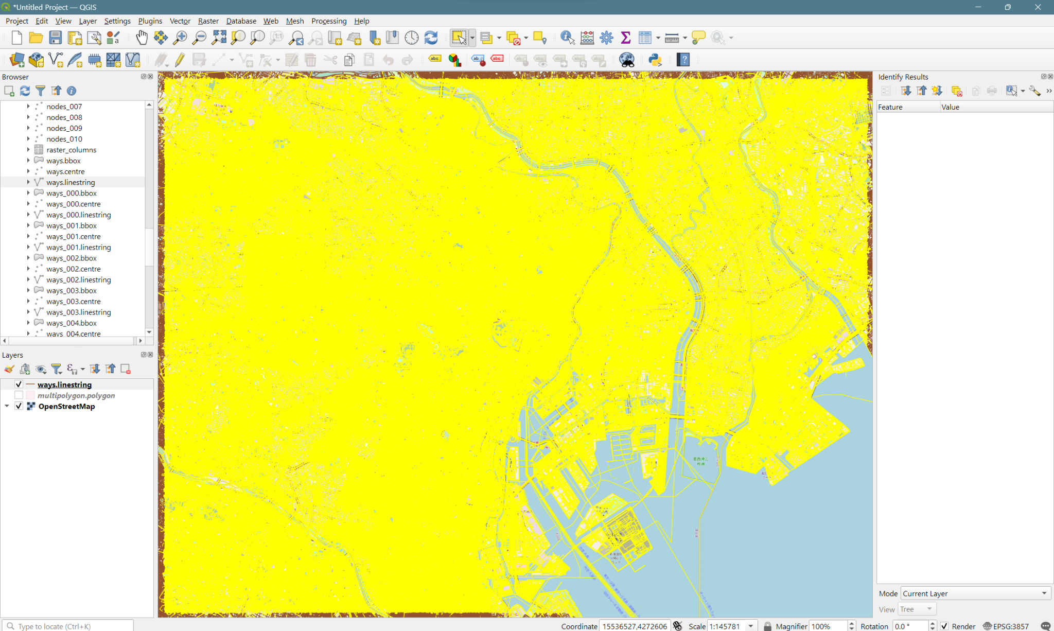Background map © OpenStreetMap contributors

Example of a way representing a building:

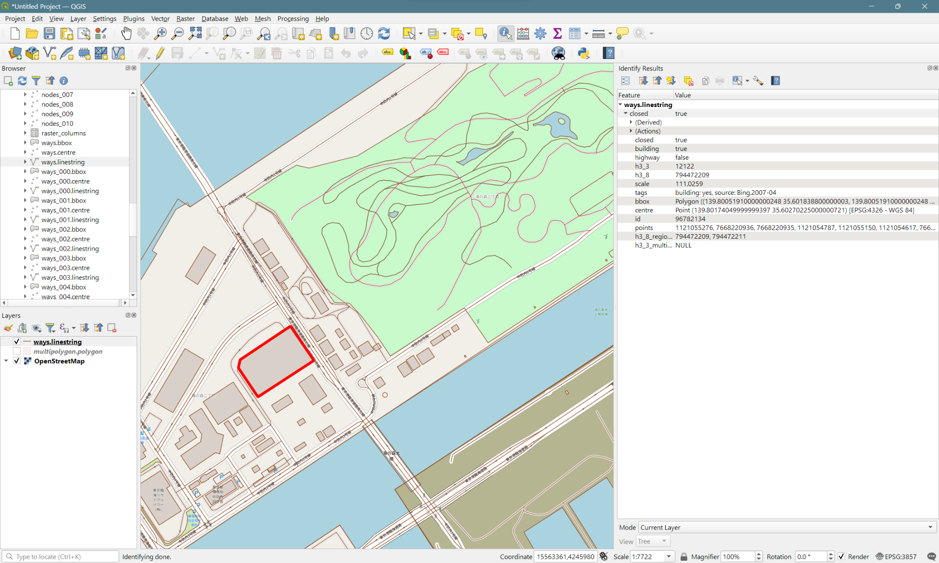Background map © OpenStreetMap contributors

Way representing a park:

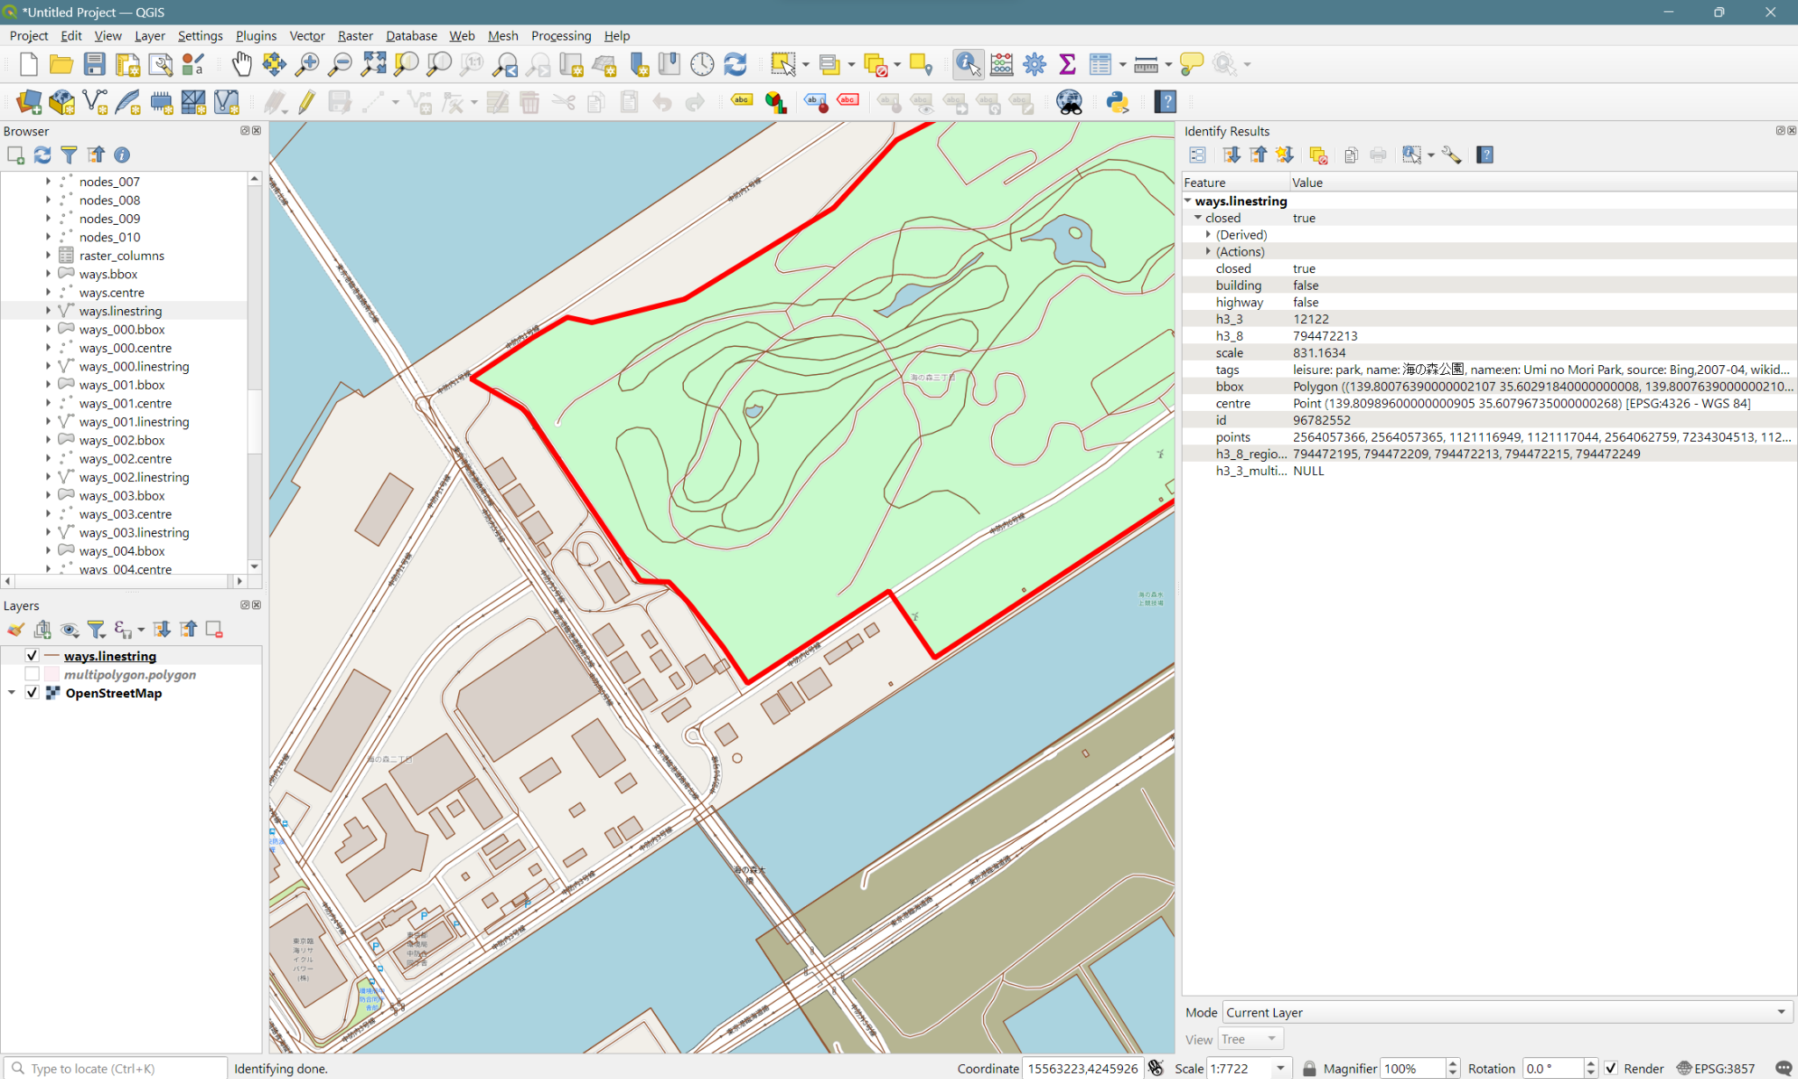Background map © OpenStreetMap contributors

Example of a multipolygon object (Omaezaki-shi, Shizuoka-ken) straddling multiple h3_3 areas, with its tags:

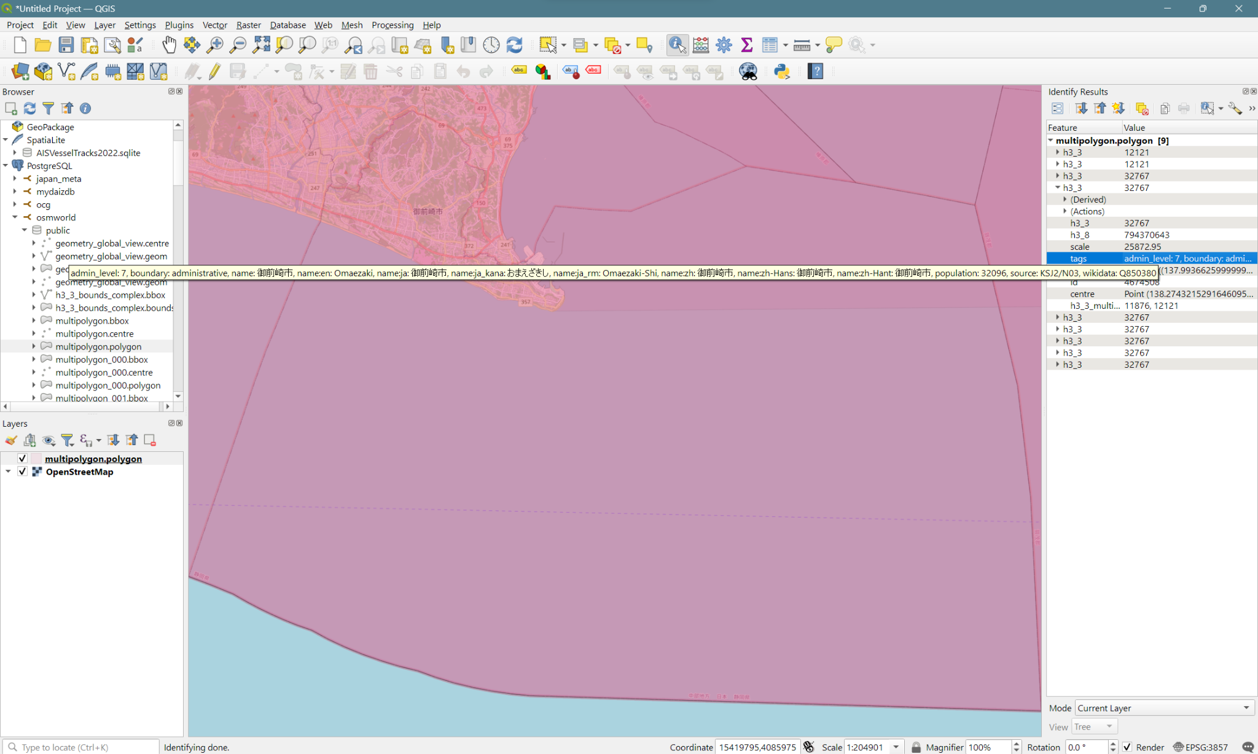

Background map © OpenStreetMap contributors

Ways that cross multiple h3_3 regions (and some ways in neighboring countries):

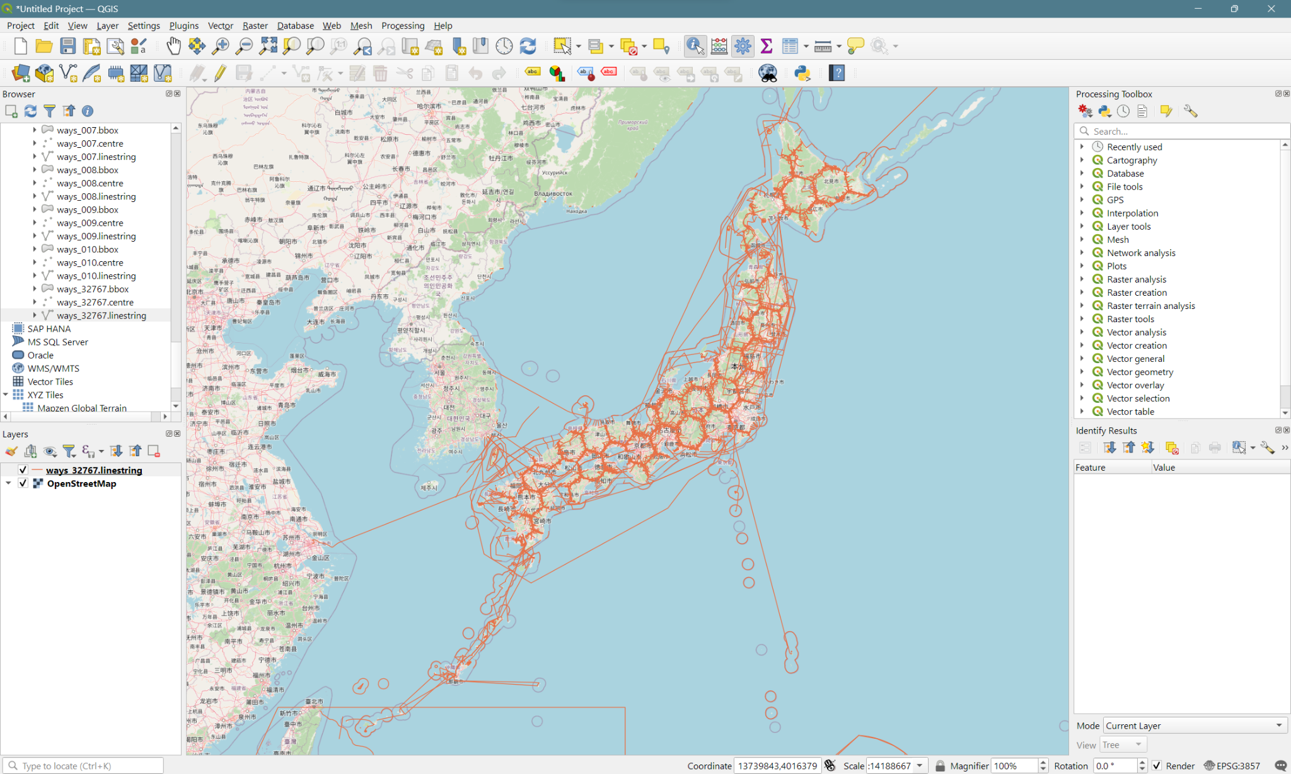

Background map © OpenStreetMap contributors

Multipolygons that cross multiple h3_3 regions:

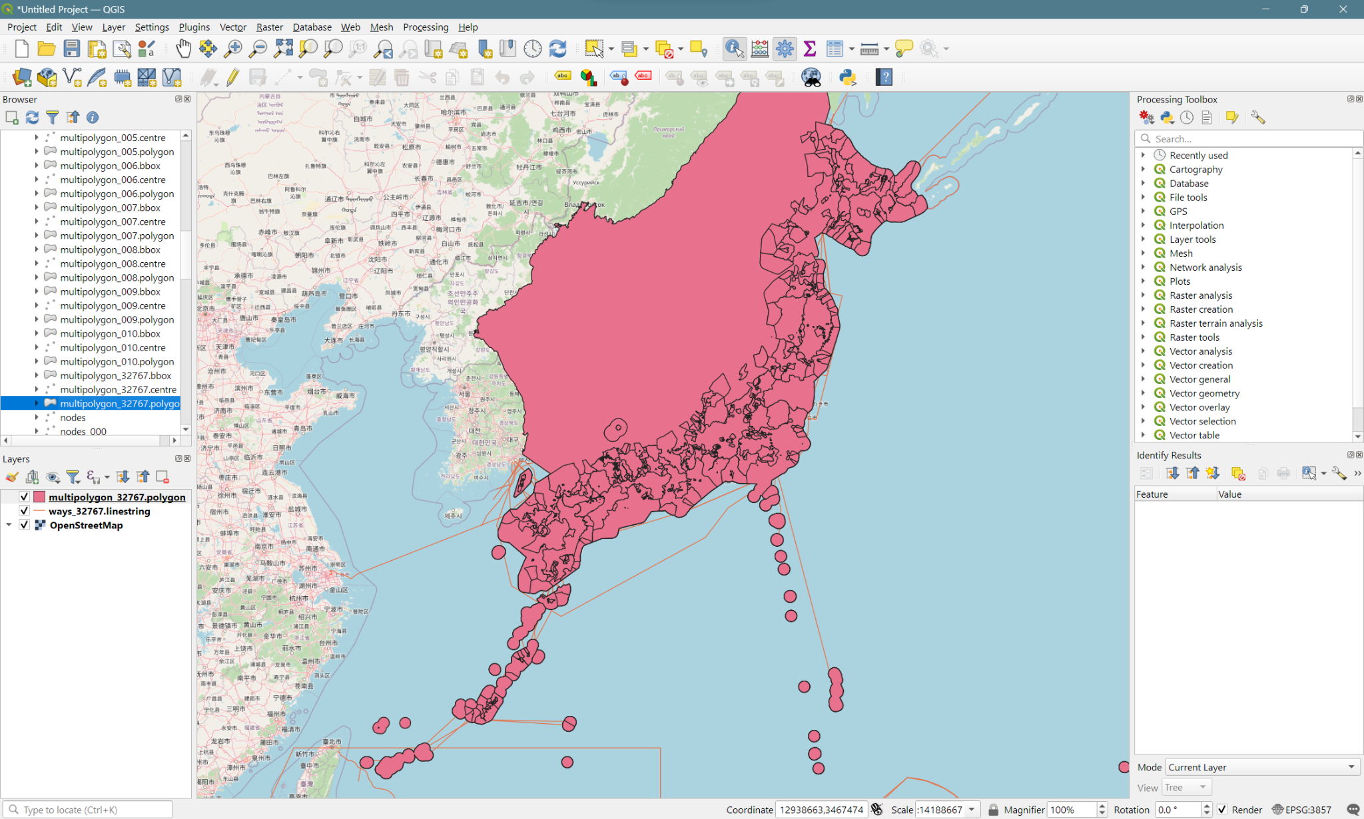Background map © OpenStreetMap contributors

# Routing

## Data extract

Ways have a “points” attribute with comma-separated list of OSM IDs of nodes. These nodes often do not have tags, so by default they are not extracted into the “nodes” table. To keep all nodes, the option “preserve_all_nodes” needs to be used when running the tool.

Two ways that share an intersection (a node) will have the same node ID in their “points” attribute. If we have all nodes, we can cut ways using the nodes referenced by their “points” attribute.

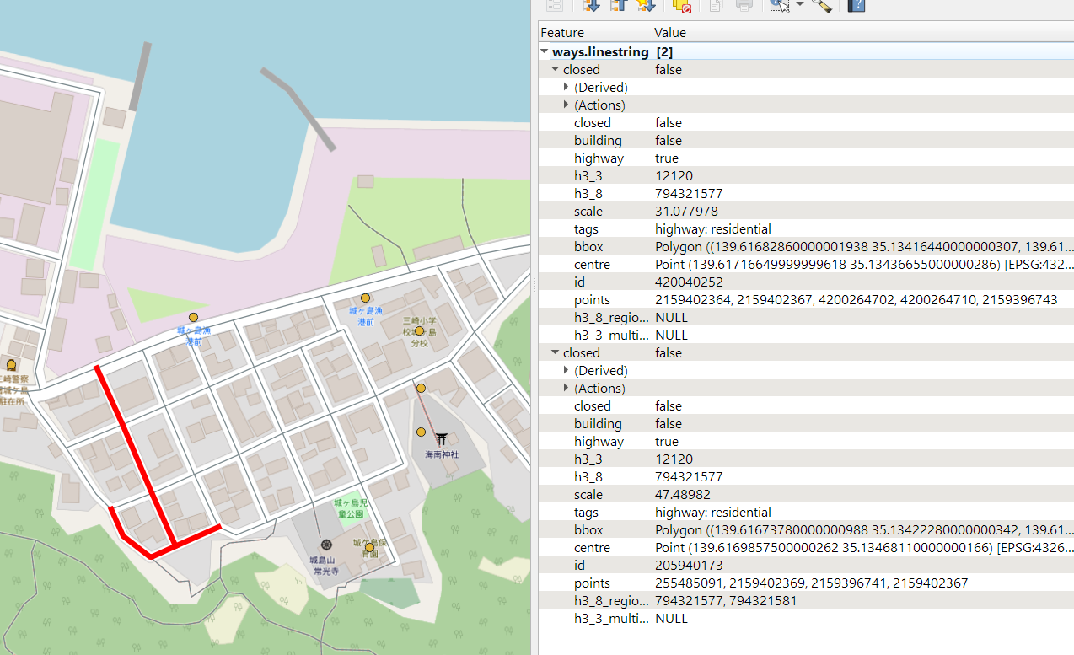Background map © OpenStreetMap contributors

## Edges and nodes creation

### Map nodes to ways

Create a ways_nodes relation table by unnesting the “points” array field of the table “ways”. Then create an index on node_id, including the column way_id. Create another index on way_id, i (position of the node within the way).

CREATE TABLE ways_nodes AS

SELECT w.h3_3 AS way_h3_3, w.id AS way_id, cardinality(w.points) AS max_i,

n.h3_3 AS node_h3_3, pts.node_id, pts.i, ST_PointN(w.linestring, pts.i::integer) AS geom,

w.tags->'level' AS "level", w.tags->'highway' AS highway, w.tags->'route' AS route

FROM ways w, unnest(w.points) WITH ORDINALITY pts(node_id, i)

LEFT JOIN nodes n ON pts.node_id=n.id

WHERE w.highway OR w.tags->'route'='ferry';

CREATE INDEX ways_nodes_node_way_idx

ON public.ways_nodes USING btree

(node_h3_3 ASC NULLS LAST, node_id ASC NULLS LAST)

INCLUDE(way_id);

CREATE INDEX ways_nodes_way_i_idx

ON public.ways_nodes USING btree

(way_id ASC NULLS LAST, i ASC NULLS LAST);

[TODO] What to do with area=yes?

### Extract intersections

Group the ways by node and keep only the nodes referenced more than once. Add a primary key.

CREATE TABLE nodes_ways_count AS

SELECT node_h3_3, node_id, array_agg(way_id) AS ways, count(*) AS cnt

FROM ways_nodes

GROUP BY node_h3_3, node_id

HAVING count(*)>1;

ALTER TABLE public.nodes_ways_count

ADD PRIMARY KEY (node_h3_3, node_id);

[TODO] There may be issues when the same way references the same node consecutively.

[TODO] There are cases where the ways are on different levels (indoor mapping)

### Create edges

Create a table of edges by separating the ways at intersections. Add a primary key constraint and indexes.

CREATE TABLE edges AS

SELECT way_h3_3, way_id,

CASE WHEN n=1 AND "end"=max_i THEN way_id ELSE way_id*1e5 + n END AS "id",

"source", target, tags,

ST_MakeLine(geom ORDER BY i ASC) AS linestring,

ST_Length(ST_MakeLine(geom ORDER BY i ASC)::geography) AS len

FROM (

SELECT way_id, row_number() OVER pts -1 AS n,

lag(node_id) OVER pts AS "source", node_id AS target,

lag(i) OVER pts AS "start", i AS "end"

FROM ways_nodes

LEFT JOIN nodes_ways_count USING (node_id)

WHERE i=1 OR i=max_i OR cnt>1

WINDOW pts AS (PARTITION BY way_id ORDER BY i ASC ROWS 1 PRECEDING)

ORDER BY way_id ASC

) t1

LEFT JOIN ways_nodes USING (way_id)

LEFT JOIN ways ON way_id="id"

WHERE n>0 AND i>="start" AND i<="end"

GROUP BY 1, 2, 3, 4, 5, 6

ORDER BY 1, 3 ASC;

ALTER TABLE public.edges

ADD CONSTRAINT edges_pkey PRIMARY KEY (id);

CREATE INDEX edges_linestring_idx

ON public.edges USING gist (linestring);

CREATE INDEX edges_way_h3_id_idx

ON public.edges USING btree

(way_h3_3 ASC NULLS LAST, way_id ASC NULLS LAST)

TABLESPACE pg_default;

[TODO] Decide what to do on including the tags or not

### Create vertices

CREATE TABLE vertices AS

SELECT h3_3, "id", in_edges, out_edges, geom

FROM nodes_ways_count

LEFT JOIN nodes ON (node_h3_3, node_id)=(h3_3, "id")

LEFT JOIN (SELECT target, array_agg("id") AS in_edges FROM edges WHERE target IS NOT NULL GROUP BY target) ei ON node_id=target

LEFT JOIN (SELECT "source", array_agg("id") AS out_edges FROM edges WHERE "source" IS NOT NULL GROUP BY "source") eo ON node_id="source";

ALTER TABLE public.vertices

ADD CONSTRAINT vertices_pkey PRIMARY KEY (h3_3, id);

CREATE INDEX vertices_geom_idx

ON public.vertices USING gist (geom);



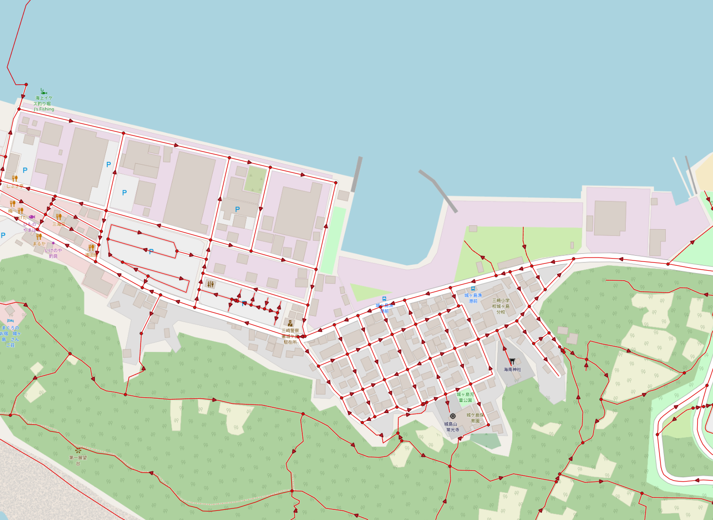

Background map © OpenStreetMap contributors

A visualization of edges and vertices. The arrows indicate the direction of the segments as originally created in OSM.

## Routing with pgRouting

### Preparation

Create the extension:

CREATE EXTENSION pgrouting CASCADE;



Create a view of edges with cost and reverse_cost columns. For a simple start, we use the length of the linestring geometries. A negative cost means the edge is not traversable:

CREATE VIEW edges_with_cost AS

SELECT way_h3_3, "id", "source", target,

CASE WHEN tags->'oneway'='-1' THEN -1 ELSE len END AS "cost",

CASE WHEN tags->'oneway'='yes' THEN -1 ELSE len END AS "reverse_cost"

FROM edges;

[TODO] Limit to a subset of tags->’highway’, use other tags (access…)

### Dijkstra shortest path

Now everything should be ready for routing. But running a Dijkstra shortest path search on all Japan can make the Postgres server crash, so it is better to limit it to a smaller region. In this case we use the h3_3 cell “12120” which covers the Miura and Boso peninsulas.

SELECT seq, edge, dij."cost", linestring

FROM pgr_dijkstra(

'SELECT id, source, target, cost, reverse_cost

FROM edges_with_cost

WHERE h3_3=12120',

1674521602, 1450406728, directed := true) dij

LEFT JOIN edges_with_cost ON edge="id";

[TODO] Find a way to limit automatically to the h3_3 cells that would cover a possible path.

The result of the query above links two points on both peninsulas, going through a “planned” road tunnel link (the 東京湾口道路), because at the time the edges did not include the ferry routes, and no filter is applied on the type of highways.

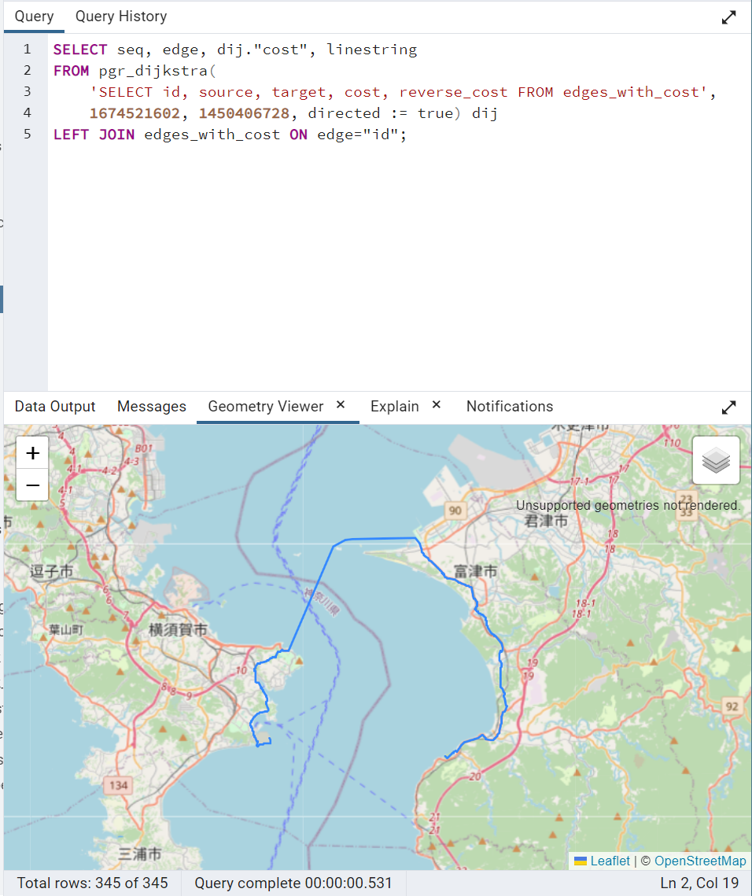

Background map © OpenStreetMap contributors

When using directly the “edges” table, and after adding the ferry routes to the network:

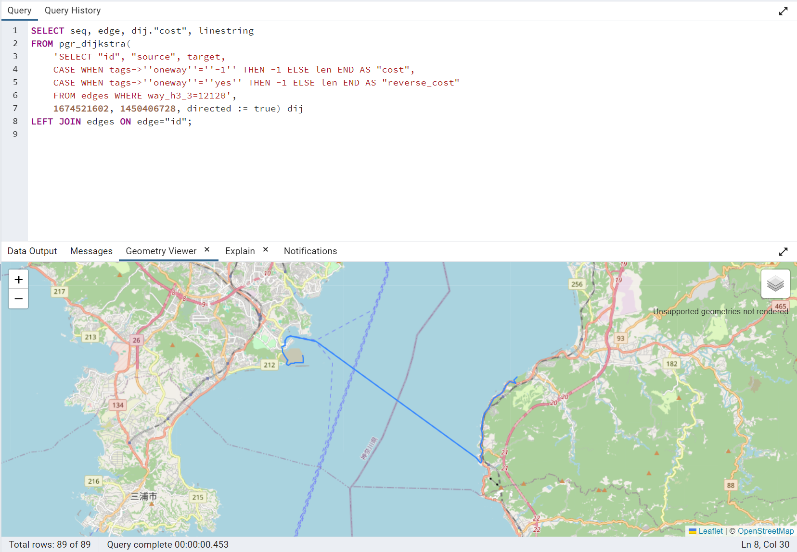

### Connected components

CREATE TABLE components AS

SELECT component, node AS node_id, geom

FROM pgr_connectedComponents(

'SELECT "id", "source", target,

CASE WHEN tags->''oneway''=''-1'' THEN -1 ELSE len END AS "cost",

CASE WHEN tags->''oneway''=''yes'' THEN -1 ELSE len END AS "reverse_cost"

FROM edges WHERE way_h3_3=12120'

)

LEFT JOIN vertices n ON node=n.id

WHERE n.h3_3=12120;

CREATE INDEX components_geom_idx

ON public.components USING gist (geom);



There are small groups of nodes that are obviously not connected to the rest, but others look like they should be connected, so it must come from issues in way-node linking in OSM.

[TODO] To investigate.

### Nodes

SELECT tags->'highway' AS highway, count(*)

FROM nodes WHERE tags ? 'highway'

GROUP BY 1 ORDER BY 2 DESC;

highway | count

--------------------------+--------

crossing | 287789

traffic_signals | 178912

bus_stop | 148090

stop | 26035

street_lamp | 15628

motorway_junction | 6777

turning_circle | 3974

traffic_mirror | 2297

elevator | 1928

passing_place | 956

milestone | 491

rest_area | 274

platform | 236

services | 205

speed_camera | 163

cycleway | 162

emergency_bay | 153

mini_roundabout | 124

trailhead | 107

turning_loop | 92

steps | 78

footway | 44

give_way | 40

emergency_access_point | 33

toll_gantry | 25

path | 18

traffic_signals;crossing | 16

...

SELECT tags->'highway' AS highway, count(DISTINCT id), count(relation_id), count(DISTINCT relation_id)

FROM nodes

LEFT JOIN relation_members ON id=member_id AND member_type='N'

WHERE tags ? 'highway'

GROUP BY 1

ORDER BY 2 DESC;

"highway" "count" "count-2" "count-3"

"crossing" 287789 170 122

"traffic_signals" 178912 4622 4513

"bus_stop" 148090 257357 12794

"stop" 26035 29 29

"street_lamp" 15628 2 1

"motorway_junction" 6777 1596 1595

"turning_circle" 3974 6 5

"traffic_mirror" 2297 1 1

"elevator" 1928 142 101

"passing_place" 956 0 0

"milestone" 491 68 13

"rest_area" 274 1 1

"platform" 236 305 190

"services" 205 0 0

"speed_camera" 163 3 3

"cycleway" 162 0 0

"emergency_bay" 153 0 0

"mini_roundabout" 124 0 0

"trailhead" 107 9 9

"turning_loop" 92 0 0

"steps" 78 28 11

"footway" 44 0 0

"give_way" 40 0 0

"emergency_access_point" 33 0 0

"toll_gantry" 25 0 0

"path" 18 0 0

"traffic_signals;crossing" 16 5 5

"track" 9 0 0

"proposed" 8 0 0

"unclassified" 8 0 0

"raceway" 6 0 0

"construction" 4 0 0

"tertiary" 4 0 0

"priority" 2 0 0

"secondary" 2 0 0

"corridor" 1 0 0

"via_ferrata" 1 0 0

"road" 1 0 0

"primary" 1 0 0

"pedestrian" 1 0 0



## Public transport

### Nodes

#### Stop position

Used for:

1. **Bus**
2. **Train**
3. Subway
4. Tram
5. Unspecified
6. Light rail
7. Train + Subway
8. Monorail
9. Ferry

SELECT count(*) FROM nodes WHERE tags->'public_transport'='stop_position';

count

-------

27514

SELECT tags->'train' AS train, tags->'subway' AS subway, tags->'monorail' AS monorail, tags->'light_rail' AS light_rail, tags->'tram' AS tram, tags->'bus' AS bus, tags->'funicular' AS funicular, tags->'aerialway' AS aerialway, tags->'share_taxi' AS share_taxi, tags->'ferry' AS ferry, count(*) FROM nodes WHERE tags->'public_transport'='stop_position' GROUP BY 1,2,3,4,5,6,7,8,9,10 ORDER BY 11 DESC;

train | subway | monorail | light_rail | tram | bus | funicular | aerialway | share_taxi | ferry | count

-------+--------+----------+------------+------+-----+-----------+-----------+------------+-------+-------

| | | | | yes | | | | | 12233

yes | | | | | | | | | | 11340

| yes | | | | | | | | | 1398

| | | | yes | | | | | | 636

| | | | | | | | | | 625

| | | yes | | | | | | | 396

yes | yes | | | | | | | | | 329

| | yes | | | | | | | | 194

| | | | | | | | | yes | 152

yes | | | yes | | | | | | | 24

| | | | | yes | | | yes | | 23

| | | | | | | yes | | | 23

yes | | yes | | | | | | | | 22

| | | yes | yes | | | | | | 17

| | | | | | yes | | | | 15

| | | | | | | | yes | | 14

no | yes | | | | | | | | | 12

yes | | | | | no | | | | | 11

| | | | | | | station | | | 9

yes | yes | | no | | | | | | | 8

| | | | | no | | | | | 8

yes | | | | no | | | | | | 6

| | | | no | yes | | | | | 4

yes | | | no | | | | | | | 3

no | | | | | yes | | | | | 2

| | | | yes | yes | | | | | 2

| yes | | | | | no | | | | 2

yes | | | | yes | | | | | | 2

yes | yes | | yes | | | | | | | 2

yes | no | | | | | | | | | 1

| yes | | | yes | | | | | | 1



<https://taginfo.openstreetmap.jp/search?q=public_transport%3Dstop_position>:



#### Bus stop

highway=bus_stop

Used with

SELECT tags->'highway', tags->'railway', tags->'amenity', tags->'public_transport', count(*) FROM nodes WHERE tags ? 'public_transport' GROUP BY 1,2,3,4 ORDER BY 5 DESC;

highway | railway | amenity | public_transport | count

-----------------+-------------------------------+---------------------------+-----------------------+--------

bus_stop | | | platform | 119912

| stop | | stop_position | 13360

| | | stop_position | 9547

| station | | station | 7606

bus_stop | | | stop_position | 3866

| | | platform | 2054

| | | station | 695

| tram_stop | | stop_position | 638

| | bus_station | station | 433

| | ferry_terminal | station | 402

platform | | | platform | 229

| station | | stop_position | 53

| halt | | station | 47

bus_stop | | bus_station | platform | 29

| | ferry_terminal | stop_position | 28

bus_stop | | bus_station | station | 22

bus_stop | | | station | 20

| | taxi | platform | 10



### Nodes / Areas (ways)

#### Bus station

amenity=bus_station

### Ways

#### Railway

### Relations

#### Stop area

SELECT tags->'public_transport', count(*) FROM relations WHERE tags->'type'='public_transport' GROUP BY 1 ORDER BY 2 DESC;

?column? | count

-----------------+-------

stop_area | 7616

stop_area_group | 343

| 8

station | 4

platform | 2

route | 1

stop_ares | 1

stop_position | 1

SELECT tags->'public_transport', member_type, count(*) FROM relations LEFT JOIN relation_members ON id=relation_id WHERE tags->'type'='public_transport' GROUP BY 1,2 ORDER BY 1,2;

?column? | member_type | count

-----------------+-------------+-------

platform | N | 6

platform | W | 1

route | N | 12

route | W | 146

station | N | 14

station | W | 15

stop_area | N | 30904

stop_area | R | 93

stop_area | W | 6326

stop_area_group | N | 52

stop_area_group | R | 816

stop_area_group | W | 8

stop_ares | N | 8

stop_position | N | 6

| N | 32

| R | 40

| W | 10

